Eros-Magento

The client wants to build a fresh e-commerce website. Where they can sell their products. And Customer also wants a warehouse management system where they can easily maintain their courier service.
My role is to help customer to create an infrastructure architecture, build, test and secured website on AWS.

ARCHITECHTURE DIAGRAM FOR EROS ENVIRONMENT :

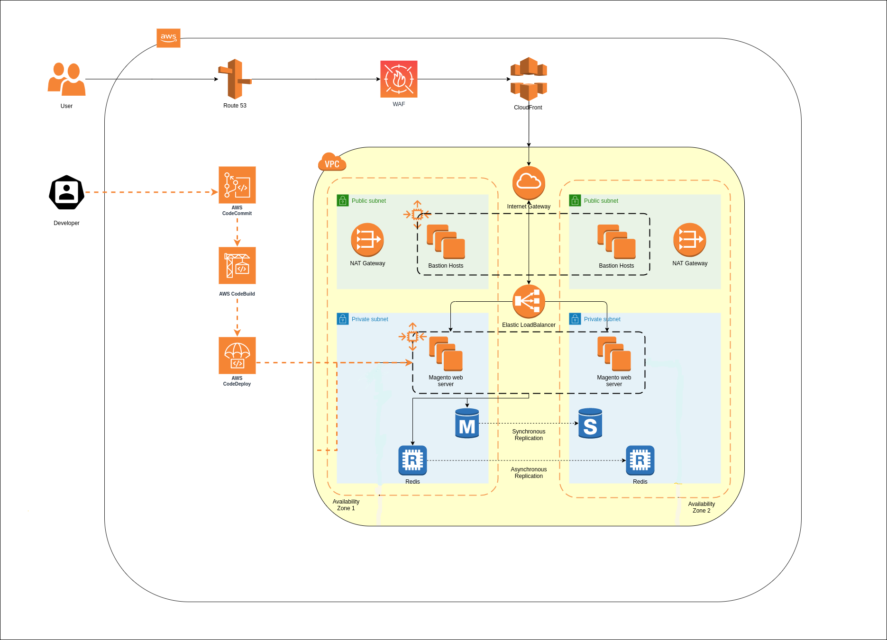

VPC

Created a VPC for Eros-Mgento with 10.0.0.0/16 CIDR

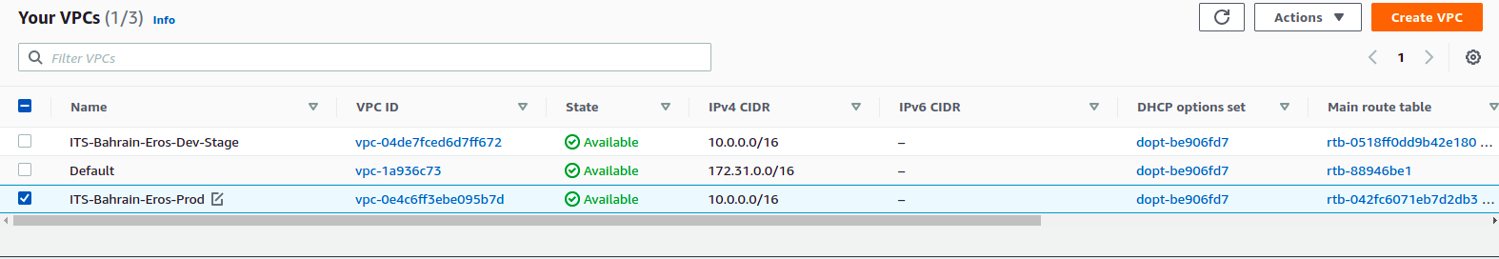
Created four Subnet for Eros-Mgento VPC
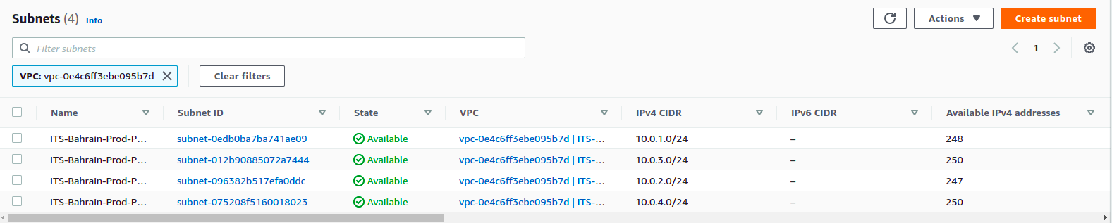
- ITS-Bahrain-Prod-Public-1a Subnet with 10.0.1.0/24
- ITS-Bahrain-Prod-Private-1b Subnet with 10.0.3.0/24
- ITS-Bahrain-Prod-Private-1a Subnet with 10.0.0.0/24
- ITS-Bahrain-Prod-Private-1a Subnet with 10.0.2.0/24

Then In Default Route Table Main, there is an internet gateway atatched and associated two public subnets.
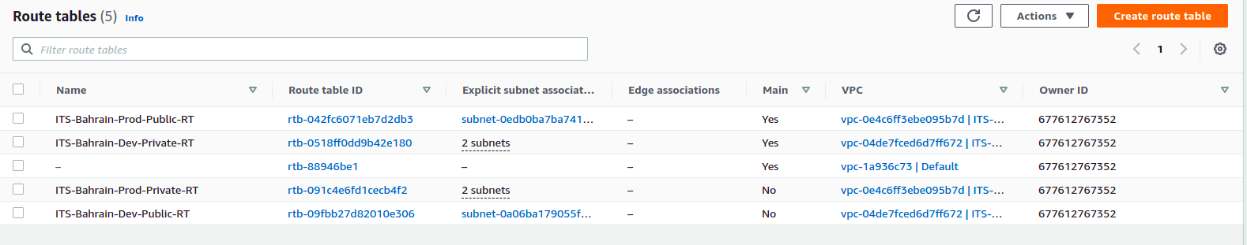
After that, created a custom Route Table with the attachment of a nat gateway and associate a private subnet.

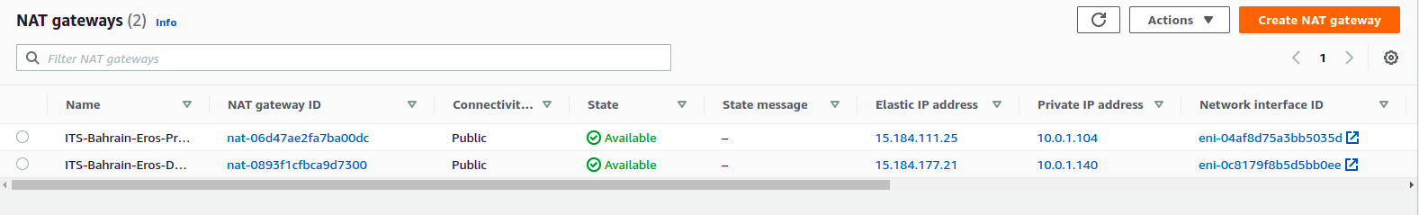

Created a Eros-Mgento internet gateway as a name Eros-Mgento and attached to the ITS-BAHRAIN-EROS-PROD VPC.
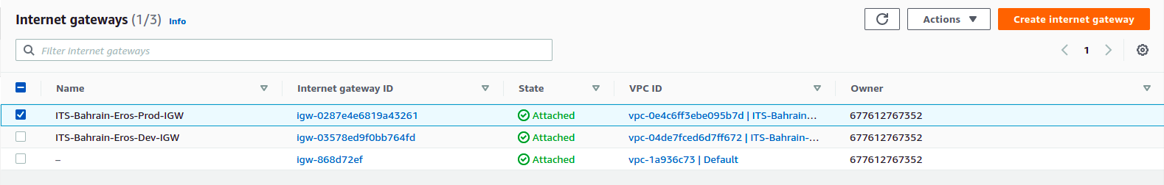

EC2

In EC2 instance, There are six instances running write now. the customer wants three instances in a private subnets, Which are Linux(ubuntu20.04) instance with the instance type of m5.xlarge, t3.large, m5.2xlarge. Another two instances which are in public subnet are for Dev and Stage are also Linux(ubuntu20.04) with the instance type of t3.xlarge.
And the remaining one instances is used as a bastion host of Linux(ubuntu20.04). Windows bastion host is t3.medium instance type.

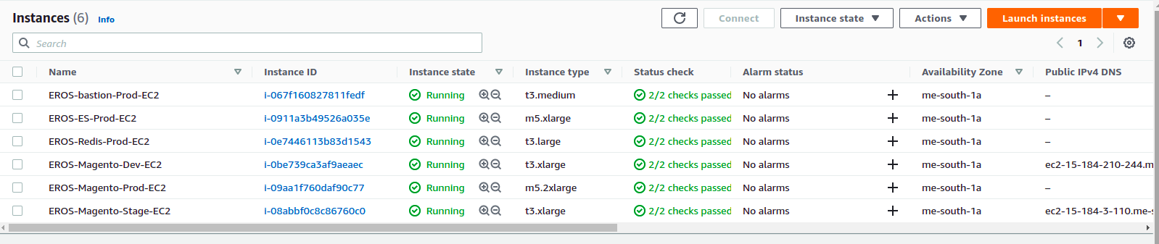

Elastic IP
Created five Elastic IP one for prod bastion server, two Elastic IP for two nat getways. and another two are for Dev and Stage servers.

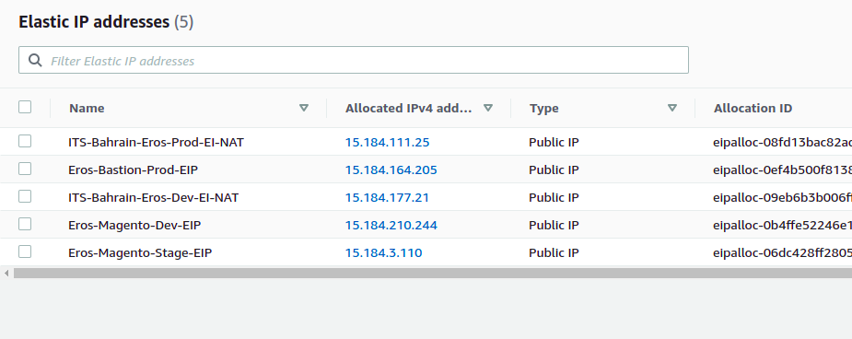
ALB
As the Linux server is in the private subnet and website is in the Linux server. Application load balancer is created so the website can access for the outer world.

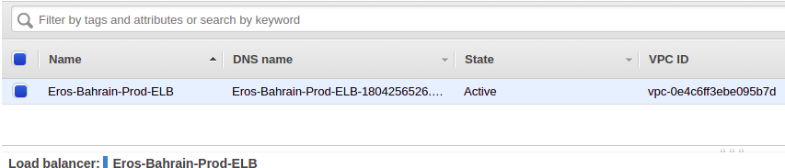

There are two target groups for the application load balancer. One for dev-stage environment and another one is for Production.

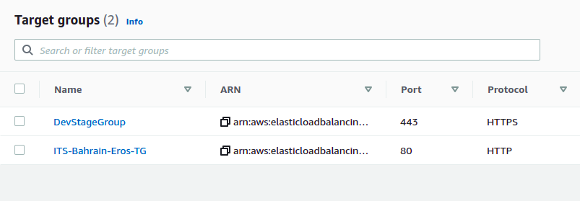

RDS

There are two RDS servers, one for Prod and another for Dev and Satging. The MySQL RDS with the size of db.t3.medium. The prod RDS is attached to the of Its-bahrain-eros-prod VPC. The storage size of this RDS is 100 GB and the storage type is a general purpose (SSD). And The prod RDS is attached to the of Its-bahrain-eros-dev-stage VPC. The storage size of this RDS is 100 GB and the storage type is a general purpose (SSD).
There is custom parameter group name as trigger with the permission of log_bin_trust_function_creators. This permission will allow the user to import the tables in database.

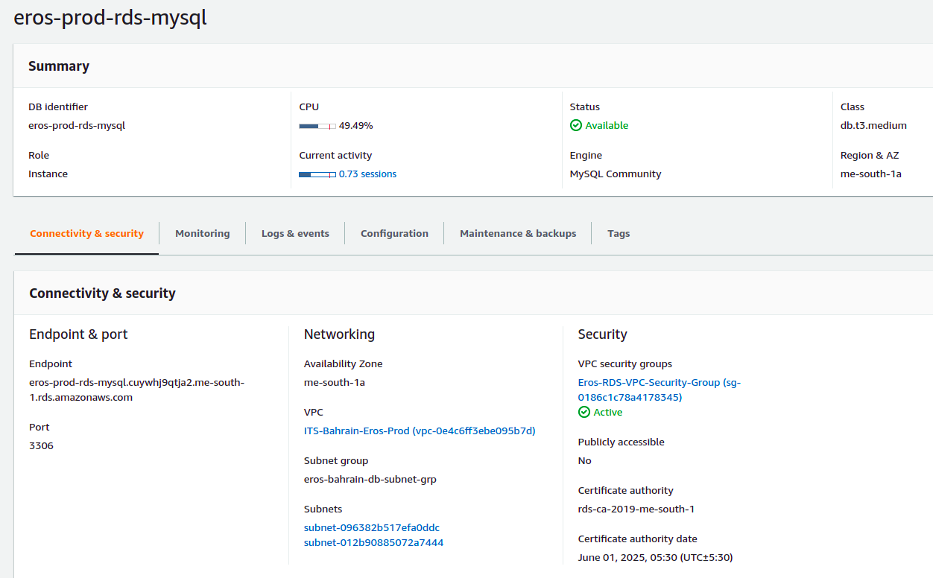

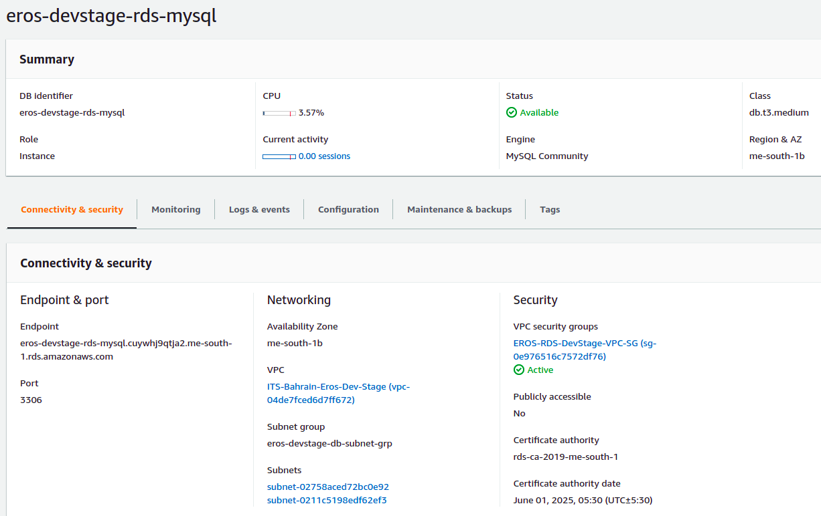

Nginx :
As I installed nginx in the linux server. And the website is built in Magento. I installed and configure the PHP7.4.3 And nginx conf file.
In apache2/sites-enabled i configure all the subdomain such as eros.ae, www.eros.ae

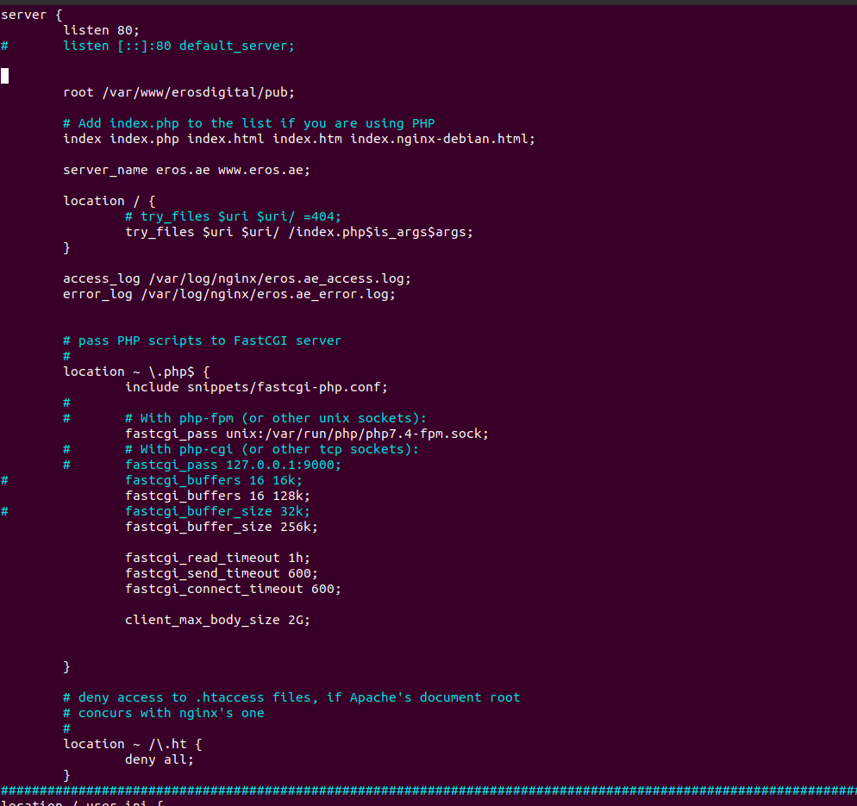

Route 53 :
As the client domain was in buyied from another domain provider, I transfer the domain into the route 53 by changing the name server. After that, I created AWS ACM certificate for eros.ae and *.eros.ae
For validating that certificate I use DNS method to authenticate.

